

Bharati Vidyapeeth (Deemed to be University) Department of Engineering and Technology

Kharghar, Navi Mumbai

**Department of Computer Science and Engineering (AIML)**

EXPERIMENT 7

|  |  |
| --- | --- |
| **Name: Shivam Bhosle** | **Roll No: 2** |
| **Subject: CV** | **Class/Batch: B1** |
| **Date of Performance:-** | **Date of Submission:** |

**AIM**

To learn corner and interest point detection using OpenCV.

**Theory**

**Corner detection**

Corner detection is a technique in computer vision used to identify points in an image where there is a significant change in the intensity or colour of the pixels. These points, known as corners, are often characterized by the presence of edges in multiple directions, making them particularly useful for various applications, such as image matching, tracking, and object recognition.

**Key Characteristics of Corners:**

* **Distinctive Features**: Corners are often more stable and distinctive than other types of features, making them reliable for matching and recognition tasks.
* **High Curvature**: Corners typically occur where the curvature of an image changes sharply.
* **Local Information**: Corners capture local structural information, which helps in understanding the shape and layout of objects in the image.

**Common Corner Detection Algorithms:**

1. **Harris Corner Detector**: Measures the change in intensity in a local neighbourhood around a pixel. It computes a score for each pixel based on the eigenvalues of the gradient covariance matrix, highlighting corners effectively.
2. **Shi-Tomasi Corner Detector**: An extension of the Harris detector that selects points with the highest minimum eigenvalue as corners.
3. **FAST (Features from Accelerated Segment Test)**: A high-speed corner detection algorithm, ideal for real-time applications.
4. **BRISK (Binary Robust Invariant Scalable Key points)**: Detects corners using a binary descriptor, making it efficient and robust to scale changes.

**Applications of Corner Detection:**

* **Image Matching**: Aligning or matching images taken from different viewpoints.
* **Object Tracking**: Following the movement of objects across frames in a video.
* **3D Reconstruction**: Estimating the 3D structure of a scene from multiple images.
* **Robotics and Navigation**: Helping robots understand their environment by detecting key features.

**Interest point detection**

Interest point detection is a computer vision technique used to identify specific points in an image that are distinct and stable under various transformations (like rotation, scaling, and changes in illumination). These points, also known as feature points, are typically more informative than other types of points in the image and are used for tasks such as image matching, object recognition, and tracking.

**Key Characteristics of Interest Points:**

* **Robustness**: Interest points are designed to be stable and reliable, meaning they should remain detectable under different conditions.
* **Distinctiveness**: They often provide significant information about the local structure of an object or scene.
* **Local Extent**: Interest points usually encompass a local neighbourhood of pixels, allowing for a detailed description of their surroundings.

**Common Interest Point Detection Algorithms:**

1. **SIFT (Scale-Invariant Feature Transform)**: Detects key points that are invariant to scale and rotation. It also computes descriptors for these points that can be used for matching.
2. **SURF (Speeded-Up Robust Features)**: A faster alternative to SIFT, SURF is also scale and rotation invariant, making it suitable for real-time applications.
3. **ORB (Oriented FAST and Rotated BRIEF)**: A free alternative that combines the strengths of FAST key point detection and BRIEF descriptors. It is efficient and suitable for real-time applications.
4. **FAST (Features from Accelerated Segment Test)**: A corner detection method that identifies corners quickly, often used in real-time applications.
5. **BRISK (Binary Robust Invariant Scalable Key points)**: Combines features of both FAST and binary descriptors for efficient and robust feature detection.

**Applications of Interest Point Detection:**

* **Image Matching**: Aligning images taken from different viewpoints or at different times.
* **Object Recognition**: Identifying objects in images based on their features.
* **3D Reconstruction**: Estimating the 3D structure of scenes from multiple images.
* **Motion Tracking**: Following the movement of features across video frames.
* **Augmented Reality**: Integrating virtual elements into real-world scenes based on detected features.

**Code & Output**

**Corner detection**

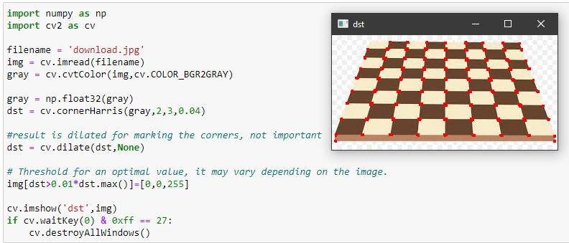

**Interest point detection**

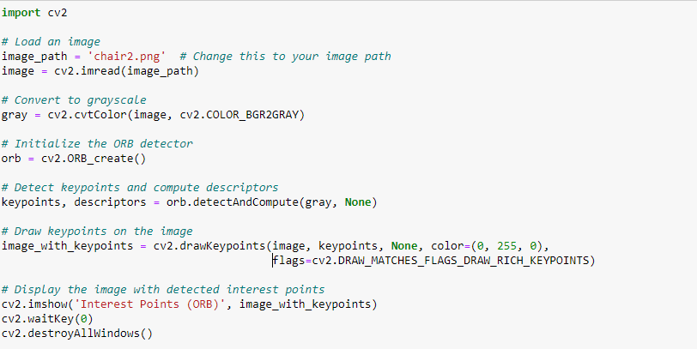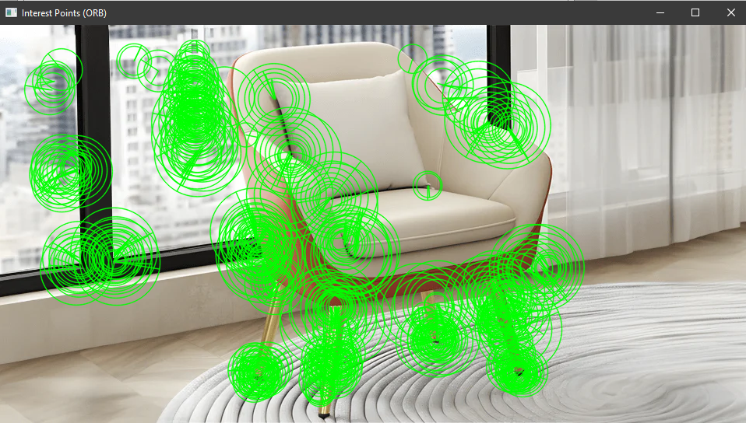

**Conclusion**

Hence, we learnt to implement corner and interest point detection using OpenCV.

**Assessment**

|  |  |  |  |  |
| --- | --- | --- | --- | --- |
| **Timely Submission (7)** | **Presentation (06)** | **Understanding (12)** | **Total (25)** | **Sign** |
|  |  |  |  |  |